**Project Initiation**

1. Purpose of the initiation phase
2. Comparing project options
3. Total cost of ownership
4. The project charter

**The Initiation Phase**

1. Business problem or opportunity defined
2. Solution is defined
3. Project is formed
4. Business case created
5. Project team appointed

**The Business Case**

1. Problem or opportunity: Detailed description
   1. Introduction
   2. Problem/opportunity statement
   3. Assumptions and Constraints
   4. Alignment with organizational objectives
2. Solutions
3. List of alternative analysis of benefits, costs, and issues
4. Description of the preferred solution
5. Main project Requirements
6. Potential risks
7. Summarized plan for implementation
   1. Schedule
   2. Financial analysis

**Financial Considerations**

Can compare projects based on

1. Net present value
2. Internal Rate of Return (Return on Investment or ROI)
3. Payback Analysis

**Net Present Value Analysis**

1. Considers the time value of money
2. Costs for future years must be discounted to the present time
3. Tangible benefits also discounted to the present time
4. Must identify an appropriate discount rate
   1. Take risk into consideration

**NPV Calculation**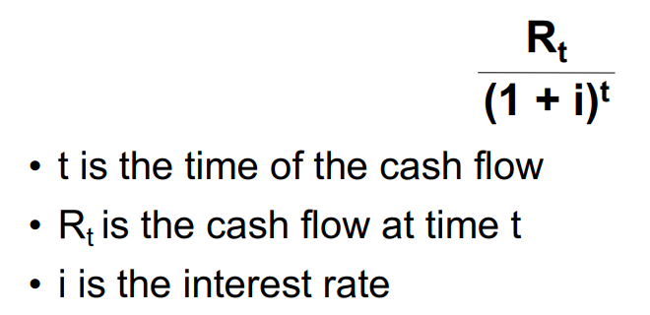

* Apply the above formula to each annual inflow and outflow of cash
* Add all terms together to get the NPV

**NPV Analysis**

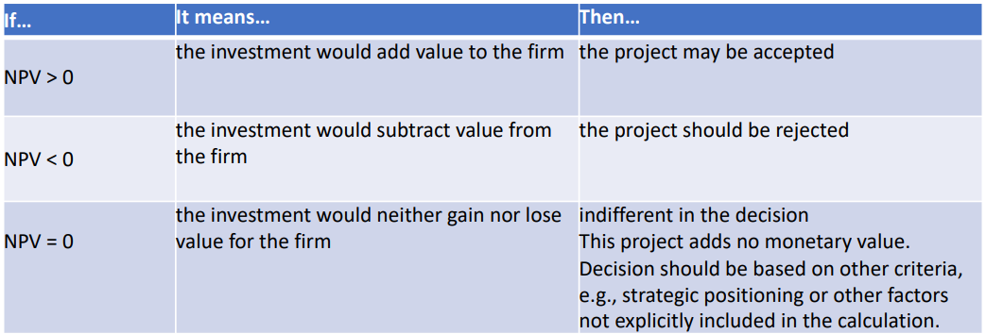

**Rate of Return**

(Total benefits – Total costs) / Total costs

1. Can be used to compare different options
2. Organizations may have a minimum acceptable rate of return for projects

**Payback Analysis**

1. Compares cumulative costs to cumulative benefits
2. Easiest to see in graphical format
3. Time on a horizontal axis, money on vertical

**The Project Charter**

**Purpose of the Project Charter**

When signed off, you have approval to proceed to detailed planning, followed by carrying out your project.

**Organizational Process Assets**

1. Is there a standard format for project charters?
2. Is there a standard process for developing and getting approval for a project charter?
3. What can the PMO do for you? What does the PMO require of you?
4. Are there applicable “lessons learned” available from other projects?
5. If you are inexperienced, is there a mentor available?
6. Etc.

**Project Charter – Typical Contents**

1. Identification section
2. Project purpose or justification
3. Measurable project objectives and related success criteria
4. High-level requirements
5. Assumptions and constraints
6. High-level project description and boundaries
7. High-level risks
8. Summary milestone schedule
9. Summary budget
10. Stakeholder list
11. Approvals

**Identification**

1. Name of the project—make it meaningful
2. Name, title, and department of a project sponsor
3. Name of project manager

**Clear Objective**

SMART

1. Specific
2. Measurable
3. Acceptable
4. Realistic
5. Time-based

**Business Need or Opportunity**

A concise statement of how the project’s deliverables will contribute to organizational objectives

**Scope**

Clearly defines what is in and out of the project

**Major Milestones**

1. Identifiable points in time
2. Target dates will be added LATER

**Major Deliverables**

Break down the overall objective into smaller measurable units

**Assumptions**

Things you are not certain of but can proceed if you behave as if they are true

**Constraints**

Anything that limits your ability to deliver or the range of acceptable solutions

**Preliminary Cost Estimates**

How will the costs be defined and controlled

**Risks**

1. High-level statement about risks identified so far
2. Include the risk of NOT doing the project

**Stakeholder List**

The stakeholders identified so far, including their roles

**Approval**

A place for the project sponsor and the project manager to sign

**Project Initiation: Summary**

1. The first phase
2. The relationship of the project to business objectives is key
3. Compare alternatives using a weighted matrix
4. Financial analysis: NPV, ROI, payback
5. Project Charter is the primary output;
   1. It includes the stakeholder list
6. Completion of Project Initiation is the signal that the project has the approval to proceed to the project planning phase.